3x3 Observations: December 2009
SOCIAL STUDIES Department – 8 Classes

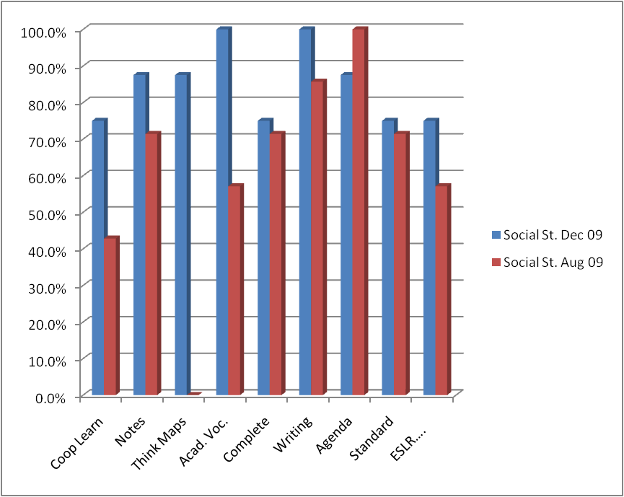

Social Studies | Coop Learn | Notes | Think Maps | Acad. Voc. | Complete Sentences | Writing | Agenda | Standard | ESLR….
Dec 09 | 75% | 88% | 88% | 10% | 75% | 100% | 88% | 75% | 75%
Aug 09 | 43% | 71% | 0% | 57% | 71% | 86% | 100% | 71% | 57%

